******

14 December 2016

******Description: Description: Macintosh SSD:Users:keith:Desktop:Logo Clifton_Terrace.jpg

***Expanding Horizons***

**For Your Diary**

**Thurs 15 Dec Last School Day (12 Noon Closure)**

**Tues 7 Feb Students Back For Day 1 2017**

Dear Parents and Caregivers,

Welcome to Week 10 here on The Terrace. When you read this the children will be excited about the fact that school will be finished for 2016.

**Rosemary Cooke’s Farewell Assembly**

On Monday afternoon, we farewelled Rosemary as she retires at the end of this term. Rosemary has been inspirational when it comes to environmental education and so it was fitting that we held the assembly opposite the ditch area beside Room 13 and 14. I call it ‘the ditch’ but it has now been renamed Aratui meaning path of the Tui. This area is now a lovely space for everyone to enjoy. One of Rosemary’s tasks on the day was to open Aratui to the children.

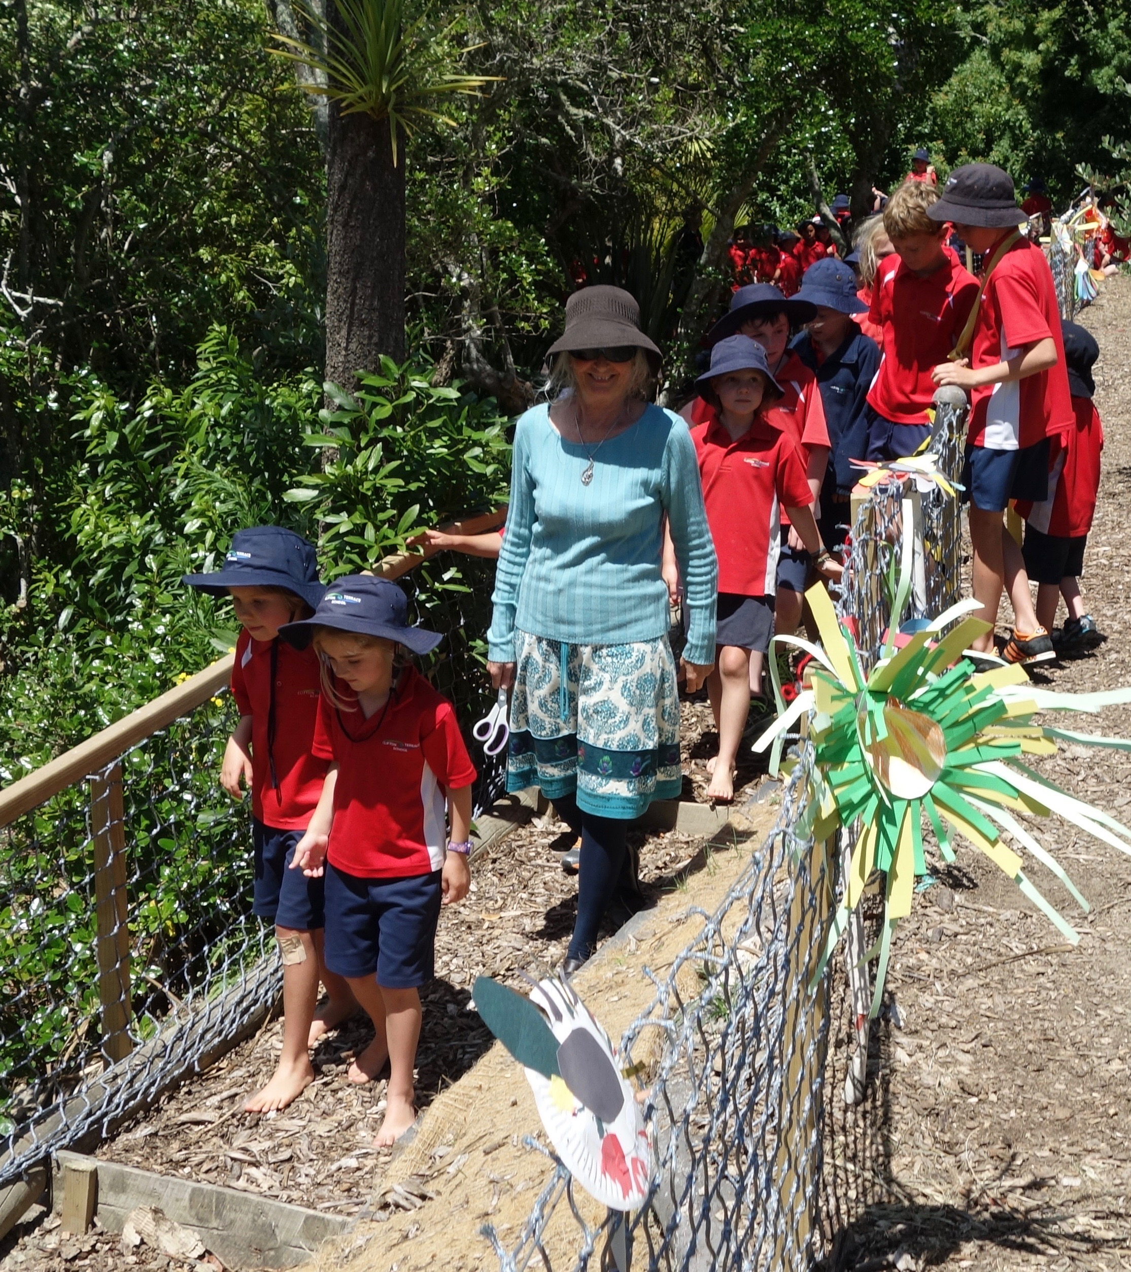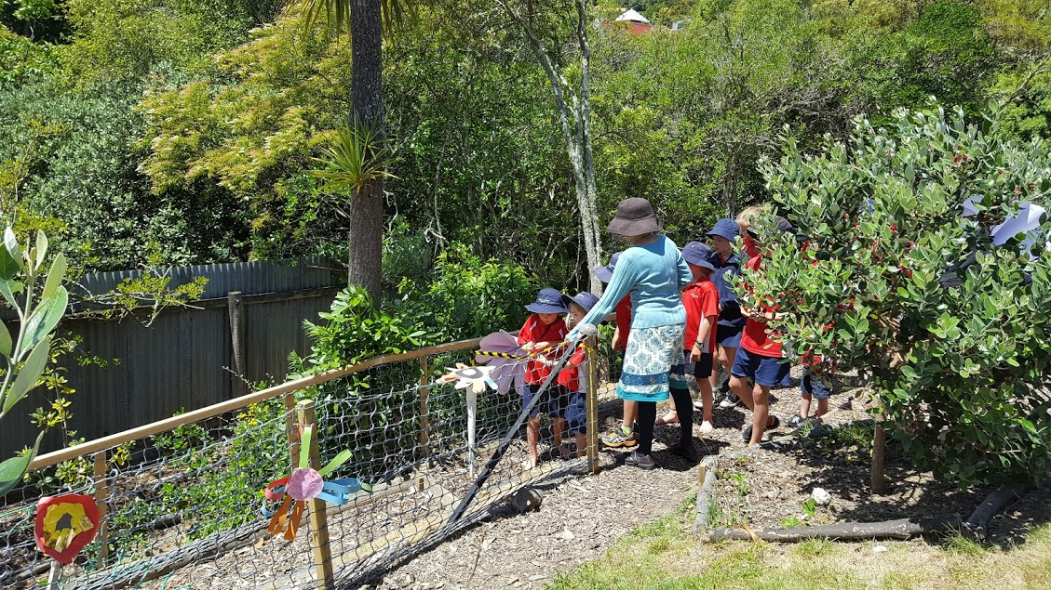I was pleased to have the opportunity to publicly thank Rosemary for all she has done in education and particularly at Clifton Terrace over the years for the many children and families.

Rosemary gifted a walnut tree and several books to the school which I would like to thank her for. We also planted 2 mandarin trees on the far side of the field area that as they fruit will remind us of Rosemary and her time here at CTS.

I am sure you will want to join me in wishing Rosemary and her family well for the years ahead and for a very happy and rewarding retirement.

**Year 6 leavers’ Assembly**

On Wednesday morning we had our Year 6 leavers assembly. This is always an emotional time as we say goodbye to students who we have known for a long time. It is also a time when we farewell families who have been associated with our school for an even longer time. I mention it being emotional as the relationships that we forge over this time are strong and the events that occur over the period of 6 year are significant in the lives of us all.

In my speech at the Year 6 Assembly, I spoke about change and how life is ever changing and that we need to keep abreast of these. Next year, whether your child attends CTS or is moving on to the next stage of schooling, there will be changes and many of these may be significant. I hope that they will take the “Expanding Horizons” spirit with them and try new things and excel in what ever they do.

In the years to come, remember to pop in and say high to us here at school. We really do love seeing your smiling faces and hearing of your exploits.

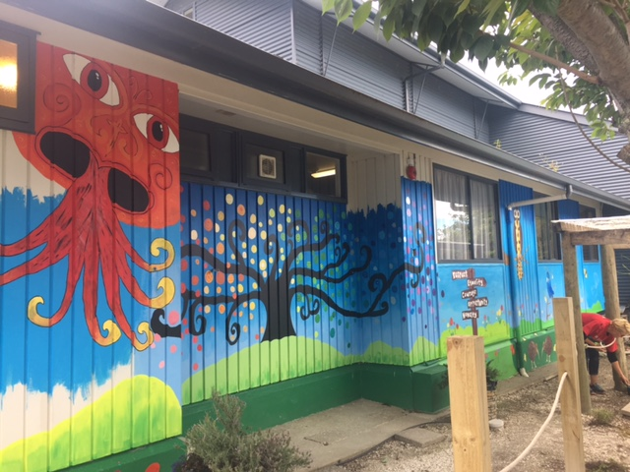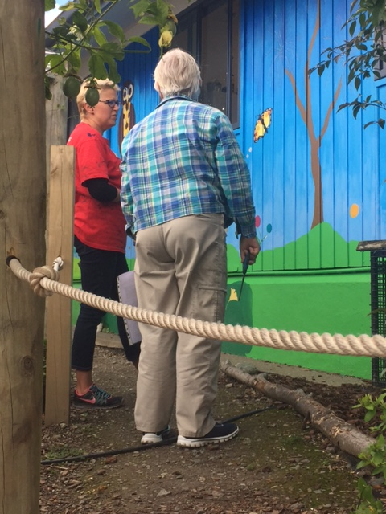You may have noticed a mural taking shape over the term opposite the library. Heather, Biddy and their team of young artists have been working on this. Thanks to everyone involved. It’s looking great and certainly brightens up this area! Thank you all so much!

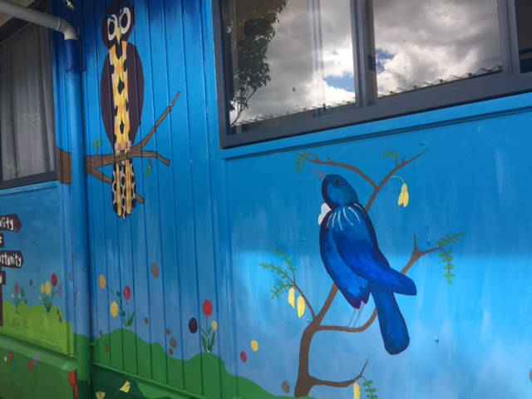

On behalf of all the staff here at CTS, I want to wish you all a very Merry Christmas. Please be safe, take care of one another and I hope you will be able to enjoy some well-earned rest with your families.

**To you all, have a very Merry Christmas and a very Happy New Year.**

** Rob Signature**

**Uniform Sales**

Any surplus uniforms that parents wish to donate to the school can be dropped at the office for H&S to sell for fundraising.  **Second hand uniforms @** [***www.cliftontce.school.nz***](http://www.cliftontce.school.nz)

**Absences from School**

You can advise school of absences by e-mail: [**office@cliftontce.school.nz**](mailto:office@cliftontce.school.nz)or text**: 027 7154058 (TEXTS ONLY) Phone 5450532 (Leave a message).**



*Looking for a babysitter or childcare during the holidays?*

Glenys Langdon (Teacher Aide at CTS) is available.

Contact her on:

545-1421

027-360-8117

**Japanese Lessons at CTS**!

Best Beginners Fridays 3:10- 3:40 (no knowledge of Japanese required, suitable for age 7 and over) $45

Star Sprouts Thursdays 3:10-3:50 or 3:55-4:35 (Japanese preK-K level of reading and writing required) $50

Growing Seedlings Mondays 3:20-4:20 (Japanese primary school level of reading and writing required) $63

Starting in the first week of Term 1

Spaces are limited so register your child now!

Contact: Mika 021 086 73773 or tmssito@gmail.com

Open Day for New Enrolments Term 1 2017

Saturday 28th January  & 4th February  10.00 am - 1.00 pm

Ballet, Irish Step Dance and Jazz are among a few of the many classes to enjoy.

Piano, Singing and Speech and Drama Lessons available at CTS in school time.

For a full list of all the different classes ASTAR offers, visit our website or Facebook page!

Schools Out for Summer!

Legend Kids is running our fantastic fun and active Holiday Programmes from 16-23 Dec and 9Jan – 3 Feb.  Come and join us for heaps of fun with plenty of trips, swimming, sports, arts, baking and more. See our website for full programme details including our special Founders Christmas week. [www.legendkids.co.nz](http://www.legendkids.co.nz/).  Bookings online or contact Cathy for more information 021 1750013, email [info@legendkids.co.nz](mailto:info@legendkids.co.nz). winz subsidies available